**Third Increment Report:**

**Team Members:**

Sidrah Junaid.

Yeruva, Vijaya Kumari

Saria Goudarzvand

**Project Overview:**

The purpose of the project is to create an application that predict the user as happy or unhappy based on his/her Twitter activities. For completing the task Twitter API is used.In our project we implemented Deep Learning algorithm using Tensorflow .

**Significance:**

The significance of the application is that the user can identify his/her lifestyle whether it is lies in happy/unhappy and on the basis of the category suggested by the application he/she can change his/her lifestyle. It also helps user to find the people having comparable interest and choices.

**Existing Services/REST API:**

Twitter APIs is used to collect tweets to implement increment3

**Implementation:**

For increment 3, we trained our simple CNN model and CNN with GLOVE using Tensor flow on the sufficient data we gathered for training to compare the accuracy of the mentioned models and applied categorization as happy and unhappy. We also implemented the Web UI through which the application can fetch the tweets of user and we saved it in TwitterStream Database in MongoDB in JSON format. The data is classified as happy/unhappy by using trained model on twitter data.

Source Code: <https://github.com/VIJAYAYERUVA/BestBuddy/tree/master/Sourcecode/BestBuddy>

**Project Management:**

Work completed:

1. We have created the training data using Twitter tweets using CNN and CNN with GLOVE using Tensorflow

2. Implemented user interface of our application using Python and Flask

3. Save the Tweets in Mongo DB



**Architecture Diagram**

**Twitter Streaming**

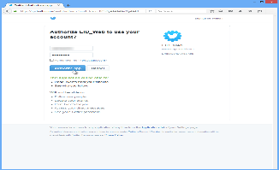







**Twitter Streaming**

**Web app using Flask Python**

**CNN Model(GloVe)**

**CNN Model**

**Details of Increment 3:**

**CNN Model with GLOVE using Tensorflow**

CNN model is used for performing visual recognition tasks and GloVe is an unsupervised learning algorithm for obtaining vector representation of words.

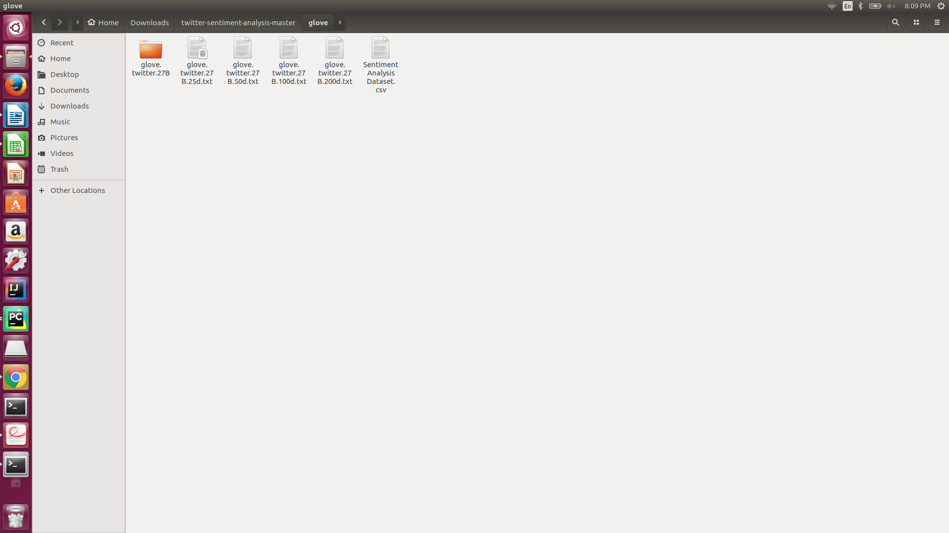

The accuracy of above mentioned model is about 53% using 30000 of twitter data, by providing more than 30000 of tweets its accuracy is 79%

**CNN Model using Tensorflow**

Here we provide two categories of tweets in negative and positive category and trained our CNN model.

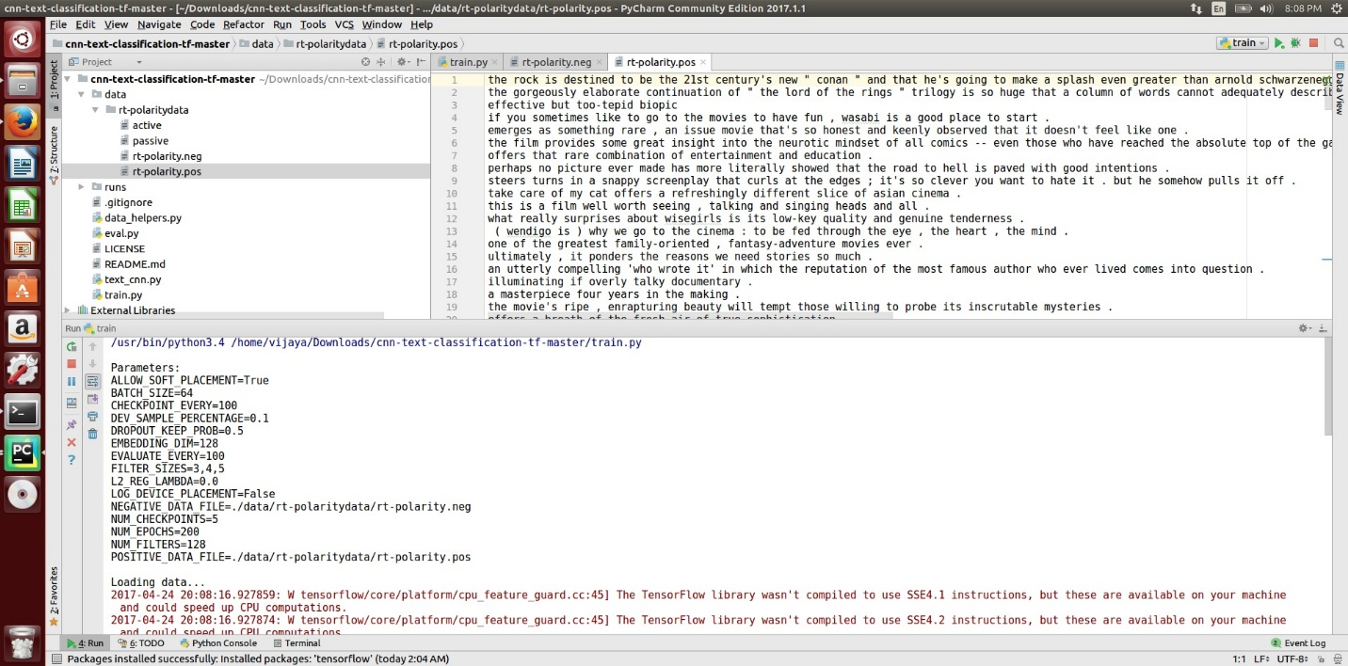

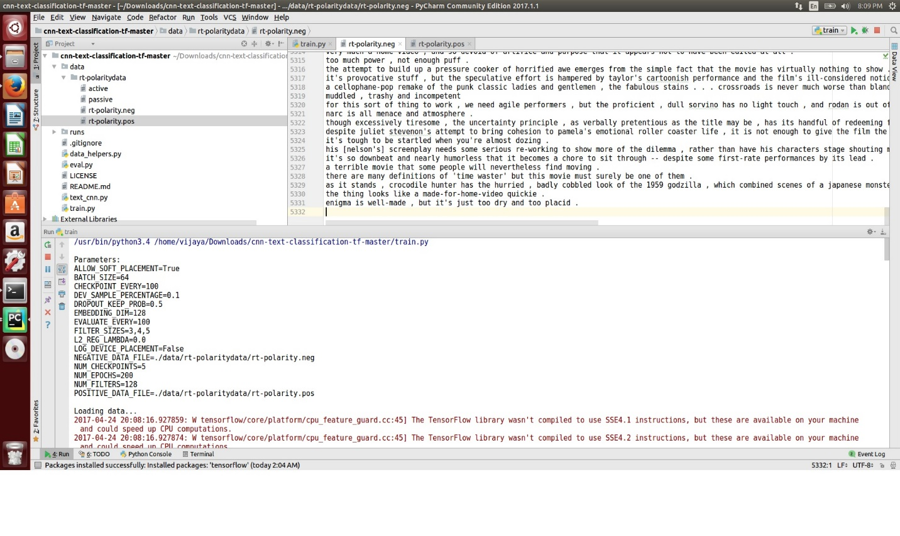

The accuracy of the CNN model on tweets data is 50%

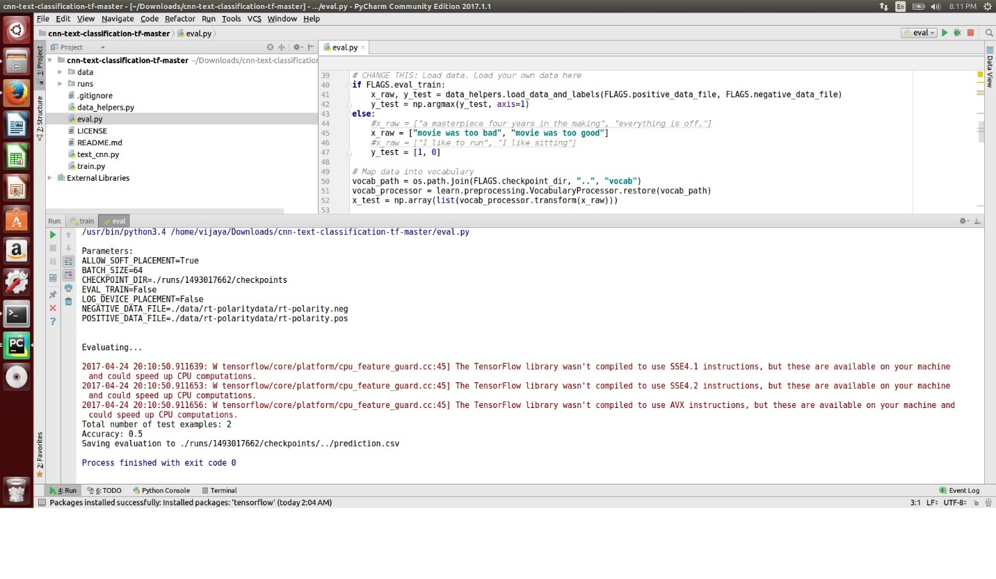

The results will be saved in csv file.

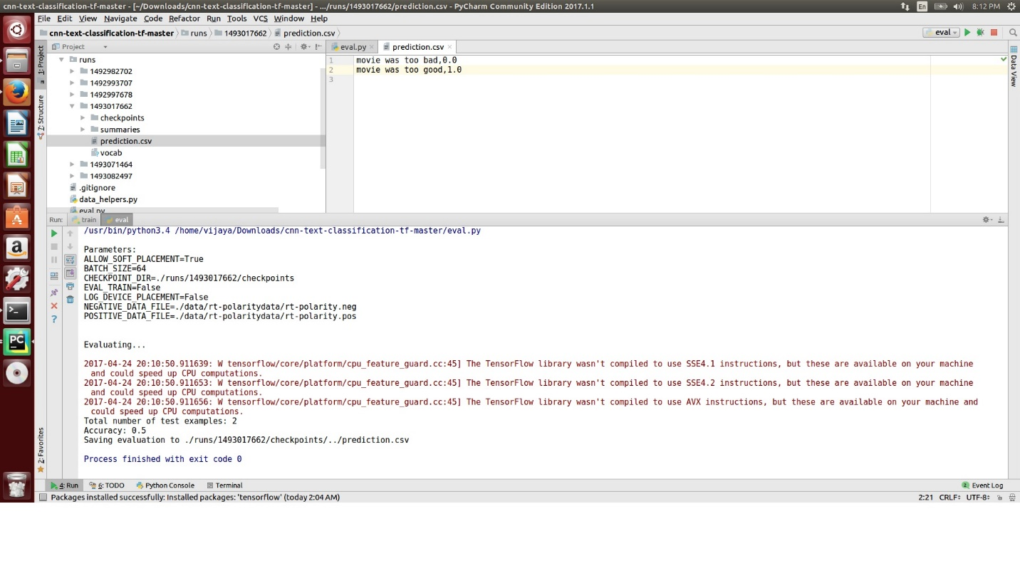

**Web Application:**

The UI of application is created using Flask a light weight Python Framework for building Webapplications.

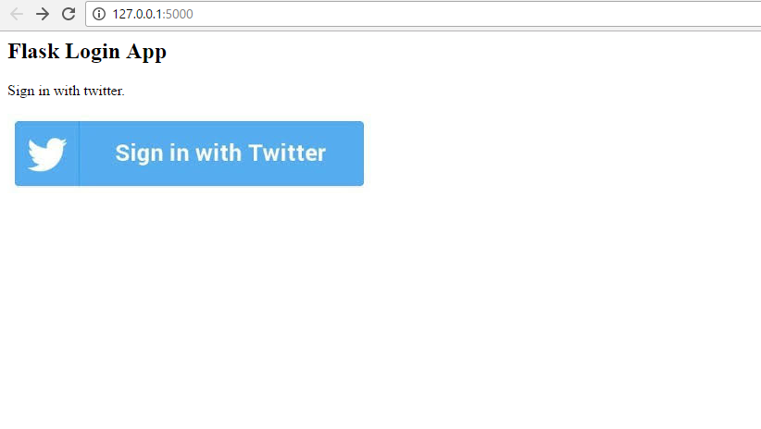

**Database:**

The database is created using MongoDB (noSQL) database.

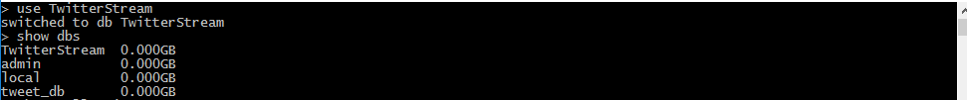

Tweet collected in **tweets** collection



Datain tweets collection in JSON format

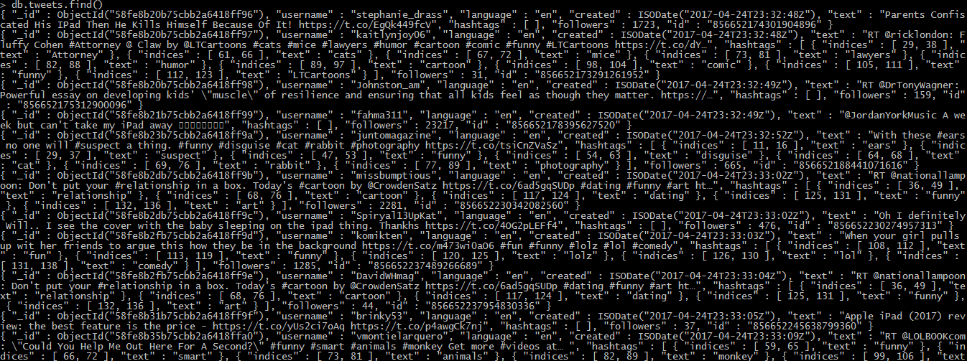

**Project Responsibilities**:

1.CNN model with GloVe using Tensorflow Saria,Vijaya,Sidrah

2.CNN model using Tensorflow Saria,Vijaya,Sidrah

3.MongoDB creation Sidrah,Vijaya(Activities),Saria

4.Webapplication using Flask Sidrah,Vijaya(Activities),Saria

**Bibliography:**

<https://www.youtube.com/watch?v=nzkrRQgCEmE>

<https://www.android.com/>

<https://dev.twitter.com/rest/collections>

<http://flask.pocoo.org/docs/0.12/>

<https://docs.mongodb.com/getting-started/shell/query/>

<https://nlp.stanford.edu/projects/glove/>

<https://github.com/keon/deep-api>